Request for Proposals

Multifamily Housing Development

Situated within the former Hospital block, this property is surrounded by the following streets:

- Southern boundary: 200 Block West Pine Avenue
- Western boundary: 800 Block North First Street
- Eastern boundary: 800 Block North Second Street

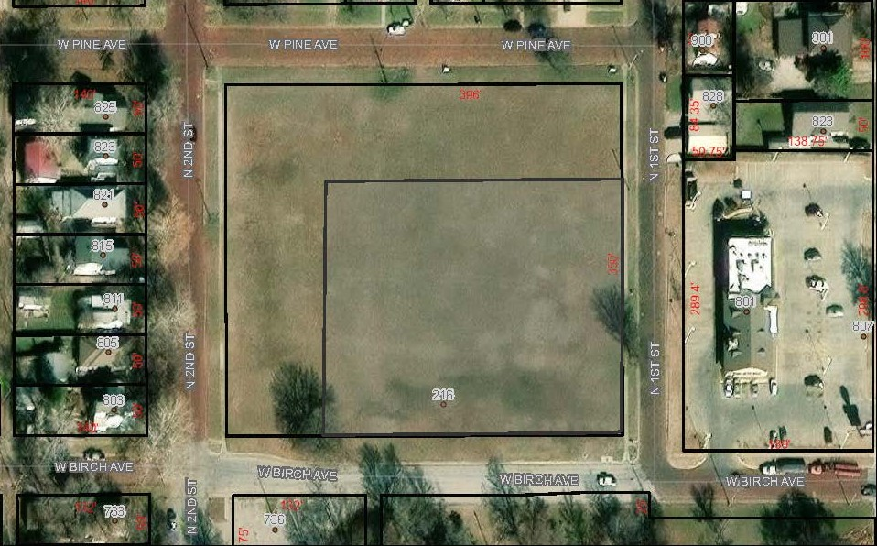

City of Arkansas City, Kansas
118 West Central Avenue
Arkansas City, Kansas 67005

March 25, 2024
City of Arkansas City, Kansas
Multifamily Housing Development
Request for Proposals

Project Introduction:
Welcome to an exciting opportunity presented by the City of Arkansas City, Kansas. We are inviting qualified real estate developers to submit proposals for the construction of multifamily housing at the Wilson Park Expansion Site, a key element of the extensive Wilson Park Master Plan.

Situated on the south side of the 200 block West Pine Avenue, west side of the 800 block North First Street, and east side of the 800 block North Second Street, we offer 1.5 acres of this prime 3.1-acre property, exclusively designated for housing development. It's important to note that this project does not qualify for property tax abatements. Instead, the incremental Ad Valorem tax generated will play a crucial role in realizing the comprehensive goals of the Wilson Park Master Plan.

Prospective developers must execute this multifamily development as a single, cohesive project, not in separate phases. The 100' strip of land on the north and west sides, spanning approximately 1.5 acres, provides a unique canvas for innovative and integrated housing solutions aligning seamlessly with the broader vision outlined in the Wilson Park Master Plan.

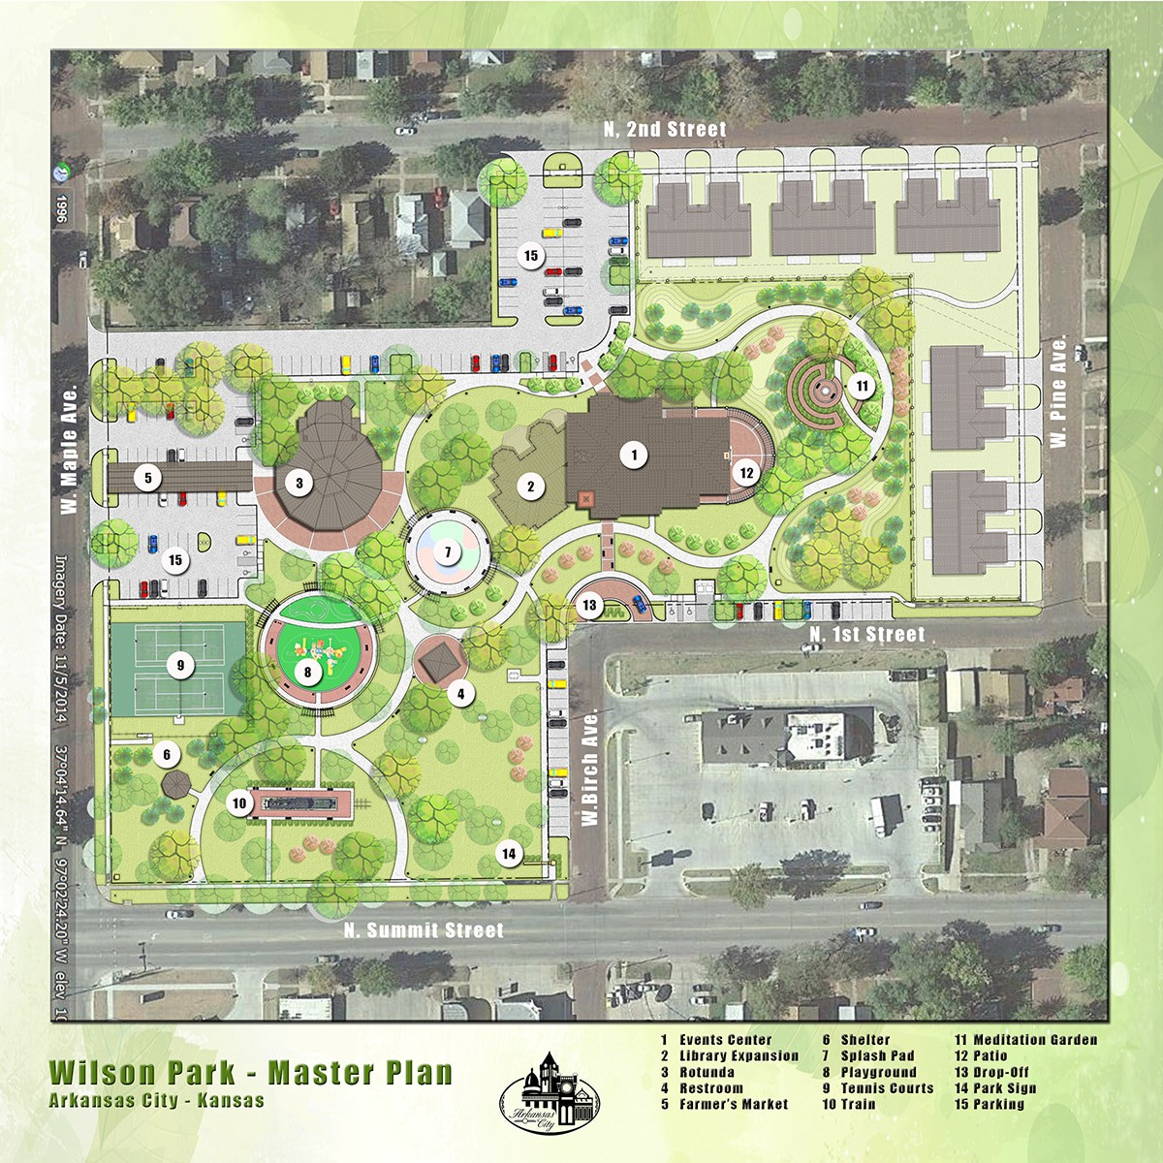
This project offers an opportunity to contribute to the growth and development of Arkansas City and be part of a visionary initiative that transcends traditional boundaries. We eagerly anticipate receiving your proposals and collaborating on the realization of a vibrant and unified community at the Wilson Park Expansion Site.
Property Overview:
A 100-foot-deep strip of land is located on the north and west sides of the property described below (350’ by 396’, former hospital block). The property is situated on the following sides:
- South side of the 200 Block West Pine Avenue
- West side of the 800 Block North First Street
- East side of the 800 Block North Second Street

Disposition Type:
The City aims to divest the property, and proposals should align with this objective. Developers are encouraged to include in their proposals any acquisition costs for the land, which can be in the form of cash contributions (to be utilized in the Wilson Park Master Plan) or in-kind services (to support the Wilson Park Master Plan).

Target Population, Housing Type, and Affordability:
Flexibility is encouraged, with a particular emphasis on ensuring that the proposed housing aligns seamlessly with the character of the neighborhood. Applicants are urged to consider the unique characteristics and aesthetics of the area when formulating their proposals. Additionally, alignment with the 2019 Housing study and the 2021 Arkansas City Housing Assessment Tool (HAT) recommendations is essential to ensure a cohesive and well-integrated approach to the development.

Submission Requirements:
Submission requirements will be communicated to interested parties upon registration.

Design Guidelines:
- Must harmonize with the neighborhood aesthetic.
- Decorative fencing must separate housing from the park.
- Required setbacks: 15 feet front, 20 feet rear.
- Buildings should have 20 feet of separation.
- Height restriction: 2 stories or 25 feet.
- Include garages with at least one space per unit.
- No additional parking required, except for the drive approach.
- Additional overflow parking shall be incorporated into the Wilson Park project.

RFP Process and Submission Requirements:
Responses are due at 4:00 p.m. on May 31st, 2024.

A. Submission Requirements:
- Full legal name, address, email, phone, and fax of the firm.
- List of corporate officers (if applicable).
- Name and title of the contact person.

B. Developer Qualifications:
- Financial capability and administrative capacity.
- Ability and experience in community engagement.
- Overall quality of the development team.
- Expertise in similar scale projects.
- References or examples of other projects
- Caliber of design professionals and proposal.
- Experience in public/private partnerships.
- Local development experience.
- Participation of minority, women, and veteran-owned businesses.

Responses:
- Written or electronic responses must be received by 4:00 pm on May 31st, 2024:
City of Arkansas City, Kansas
Attn: City Clerk
118 West Central Ave
P.O. Box 788
Arkansas City, KS 67005
(620) 441-4412
tparsons@arkansascityks.gov
- Clearly mark submissions as "City Multifamily Housing Development Request for Proposals."
- The Committee may issue addenda to facilitate the process.
- Submissions not accepted after the closing date, with no modifications permitted.
- The Committee reserves the right to reject any or all responses. The Selection Committee’s recommendation will be considered by the City Commission who has final approval.

Selection and Schedule:
Upon receiving the proposals, the Selection Committee will review and recommend a developer who best aligns with the qualifications and guidelines outlined in this RFP to the City Commission, which holds final approval authority. Subsequent negotiations will take place, and the most responsive and responsible proposer will be selected, taking into account price and other relevant factors. The Committee retains the discretion to reject any or all proposals if doing so serves the best interests of the City.

Contact Information:
City Manager, City Hall
118 N. Central Ave, Arkansas City, KS 67005
(620) 441-4414 | rfrazer@arkansascityks.gov

Thank you for your interest in contributing to the growth and enhancement of our community.

